Guinea

## Political Stability Estimate Data

The data set shows the political stability estimate of the country each year.

## # A tibble: 19 x 5  
## country iso3c date stability stabilityCategory4   
## <chr> <chr> <dbl> <dbl> <chr>   
## 1 Guinea GIN 1996 -1.15 highly unstable   
## 2 Guinea GIN 1998 -0.586 moderately unstable  
## 3 Guinea GIN 2000 -1.91 highly unstable   
## 4 Guinea GIN 2002 -1.42 highly unstable   
## 5 Guinea GIN 2003 -0.789 moderately unstable  
## 6 Guinea GIN 2004 -1.03 highly unstable   
## 7 Guinea GIN 2005 -1.16 highly unstable   
## 8 Guinea GIN 2006 -1.91 highly unstable   
## 9 Guinea GIN 2007 -2.40 highly unstable   
## 10 Guinea GIN 2008 -2.10 highly unstable   
## 11 Guinea GIN 2009 -2.12 highly unstable   
## 12 Guinea GIN 2010 -1.69 highly unstable   
## 13 Guinea GIN 2011 -1.39 highly unstable   
## 14 Guinea GIN 2012 -1.29 highly unstable   
## 15 Guinea GIN 2013 -1.23 highly unstable   
## 16 Guinea GIN 2014 -0.955 moderately unstable  
## 17 Guinea GIN 2015 -0.387 moderately unstable  
## 18 Guinea GIN 2016 -0.394 moderately unstable  
## 19 Guinea GIN 2017 -0.606 moderately unstable

## Political Stability Estimate Plot

The plot shows the trends of stabilization and destabilization for the each country.

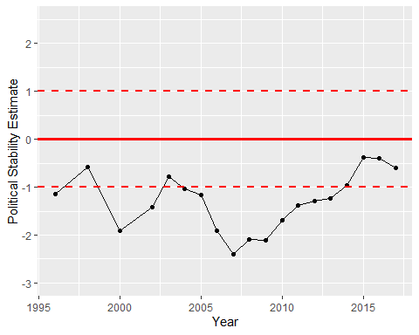

Political Stability Trend